**Chapter I**

**The Problem and Its Background**

**Introduction**

In the world where everything is instant, computers have a vital role in the society. It is used in almost everything and people interact with computer in daily aspect of life. Computers are used in helping a man’s work faster and efficient. Also, it is a tool in such a way that many innovation happen and it becomes the bedrock of our society in this present century. Data is important in any form of Business and Information, they have the power to create possibilities in a business and today in 21st Century, many company needs to have a Database Management System in order to make their work easier and hassle free management in such a way it easy to manipulate that a spreadsheets. To have a database in a Company is an asset in terms of efficiency, organizing and managing data this is been reflected in a current survey in 2016 that high demand programming that SQL is rank 1 and SQL is database programming it means that it really demand of the company to have a database.

AdManCenter for Advancement of Man Inc.(AdMan Inc.) is a privately owned corporation that is a Learning and Talent Service Provider, Event Manager and Consultancy company based in Tacloban City. The goal of the company is to **Increase the Human Capital** of the Eastern Visayas trough *high quality, meaningful, relevant, innovative, dynamic, and fun filled learning events*. Also it is a proud member of Philippine Society for Training and Development Foundation INC. (PSTD) that envisions to be haven of learning and preferred brand choice as a service provider for Learning and Talent Development and Event Management Needs at a reasonable cost.

As a Learning and Development and Consultancy Service Provider, they offers a Blended Solution to all Learning and Development needs of every organization, from the business sector, to local government units (LGU), government agencies, non-government, institutions and the academe. Anchored on a Multi and Interdisciplinary strategy, strives to foster a holistic approach to its personal and professional enhancement programs effectively advancing a **Work-Life Balanced, Value Centric**, **Client Friendly and Value for Money Learning and Development Events.** Also they offer’s a **training on demand** service that allows to create Learning and Development program tailored to the specific needs of every discerning clients. The core team is composed of highly qualified subject matter experts/industry practioners as trainer-consultants, with their intensive work experience in their respective fields of expertise ensures that our training participants would only get the best and enjoy in depth analysis and perspectives of the topics at hand. Our competitive advantage is having our lecturers/trainer–consultant as Industry Practitioners passionately sharing their valuable insights on specific topics based on actual Industry Standards and Practices.

As an Event Management and Consultancy Company provides a dynamic, hassle free management of organization’s learning events such as seminars, trainings, conference and the likes. Be it small groups to the big one the company handle it all **AdMan Inc**. work to ensure an informative, motivating, memorable and fun filled managed events.

Like any companies Adman Inc. has also many problems, one of which is poor Data Management such as security, efficiency of the system, storing and encoding of data, data redundancy, and monitoring. Also, the company face a great adversary in term of advertisement and contacting the trusted client and partners. The company believes on a B2C e-commerce that every customer must meet the desired satisfaction. In order for the company to efficiently manage its database, we the researcher, proposed an Information Management System that will effectively address this problem.

### Project Context

The current situation of the company is not going to boundary one of the problem facing is doesn’t have a specialized database software that will address in the problem of profiling and also the availability of data. Through this problem it causes a lot frustration and waste a lot resource due to this problem. Even so the company is a small scale there covered almost city, municipality, or town here in region 8. To meet the demand of the company, we the researcher will propose a database management system which will address to the company’s needs.

This system is named ADMAN DARE which means Advancement of Man Data Access Recovery Engine. This system is specialized in profiling, and has some features of web development such as the web advertisement, and email blasting. Through the use web development our propose system will meet the first business benefit is to increase the company’s popularity and this system support of following business benefits such as:

1. reducing the time of processing data;
2. reducing the complexity of data;
3. making the customer satisfaction at ease;

**Theoretical Framework**

In developing the proposed system, the different theories below have been applied by the researchers. These theories contribute to the completion of the study.

In the making of the system, the researchers will construct several designs in which it would conform to the area of the study. Based on George Miller’s TOTE (Test – Operate – Test – Exit) Theory, there are operational feedback units that function on a self- regulated system. According to this theory every individual could have a numerous TOTE’s (Test – Operate – Test – Exit). Before this behaviour occurs, there are must first be some input. Then, there must be criteria for testing the input; this is usually the comparison of some internal standards (T). Next, there must be some responses for dealing with the incongruities (O). When the input does not match with the internal standards, then some actions will be taken until the test against the internal standard is repeated (T). The TOTE (Test-Operates-Test – Exit) will only continue to cycle through iteration of TOT until the incongruity is resolute. Once the incongruities are being accomplish, the individual exit the loop with a resultant behaviour that was based on congruity (E).Furthermore, the theory entails the vulnerability/openness of a system to carry out any changes that can be applied on some specification. Thus, the researchers considered the TOTE (Test – Operate – Test – Exit) Theory that simply tells that there is no such thing as faultless system. Hence, it can be improved on a step by step process.

The Customer Focus Theory entails of gathering and analysing the customer requirement, collection and utilization of customer information, receiving and utilizing thecustomer satisfaction rating, and improvement of customer relationship, (Brigham Young University, 2012).

This theory will help the researcher to identify the needs of the client’s needs in which essential giving solution and developing the system.

The Business to Business (B2B) E-Commerce Theory according to useoftechnology.com that a business sells a product or services to another business it like a mutual relationship in enhance their knowledge in their field of work.

These theories will help the researcher to the process of the client organization.

The Component Object Model-Client (COM-Client) programming, is a framework that is been introduced by Microsoft to enable inter-process communication object creation in a large programming language. It means that every any application can interact with any application in a network or every new application can interact with the old application (MSDN.Com).

This programming model will help the researcher to meet the standards of the Client and increase efficiency user adaptability.

**Conceptual Framework**

The flowchart below shows the flow of the system the researchers will implement.

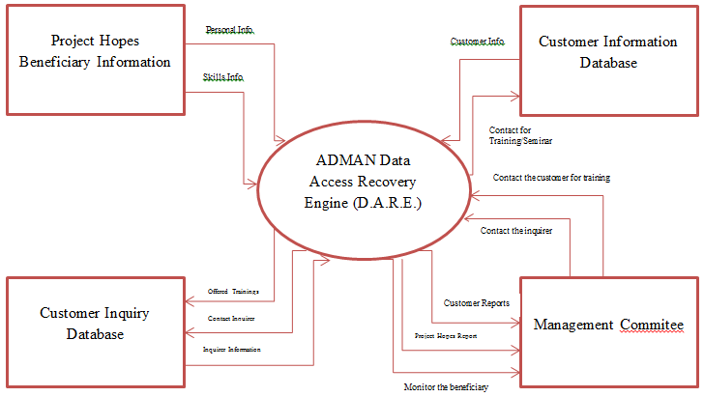

## Figure 1. Conceptual Framework

The inputs used were the information collected from the surveys of *Center for the Advancement of Man* (AdMan). We used surveys, downloaded materials, thesis books, and online articles for reference. After we identified the flow of the process, the researchers will determine the overall scope and the problems encountered in the system. After data gathering, the enhancement of the current system will follow. The opinion from the administration will also be considered as inputs for the final output. The output will be the result of careful analysis and discussion of the proponents and the organization. The output will be the AdMan Data Access Recovery Engine (D.A.R.E).

**Objective of the study**

This study aimed to develop a Database Management System (DBMS) ADMAN DARE a System Develop that has some features of web advertisement, in order to upgrade their current system. Specifically, this would like to:

1. to enhance the comfortability of the user;
2. to create a user-friendly application;
3. to reduce the likelihood of duplication;
4. to get a faster information;
5. to reach-out more indigent people;
6. to monitor the status of the beneficiary; and
7. to inform the customer for further seminar or training.

**Scope and Limitations**

This study aims to develop a database management and information system that would help improve the process of ADMAN. Specifically:

1. to create a profile of customers/potential customers;
2. to monitor the status of the beneficiary;
3. to be able to know about the needs of the beneficiary and the office;
4. to be able to advertise the company’s events;
5. to create graphs;
6. to be able to generate reports;
7. to ensure the integrity of the data;
8. to secure the data;
9. to upgrade the performance of the current system; and
10. to establish a scalable database management system.

This research is limited to:

1. the ADMAN beneficiary;
2. dissemination of information about trainings or seminars; and
3. Region VIII;

This research will not include the non-automated process such as:

1. Surveying;
2. Going to the community;
3. Participating in seminar or trainings;
4. Interviewing of the participant; and
5. Tallying data;

**Definition of Terms**

The following are the terms were used in this study:

**D-A-R-E** the complete meaning of this is Data Access Recovery Engine

**User-Friendly** means it is easy to use and faster to learn

**Likelihood** is a probability of something or chance of the possible result of what you are going to do.

**Beneficiary** is the company give a special offer to develop of their skills, talents, and work ethics

**Dissemination** is to inform many people for an event or something.

**Integrity**is the state of being complete of this information.

**Potential Customer** is an interested person, which is interested to offer of the company

**Customer** is the one who has already transaction to the company.

**Partners** is a organization that the company is tied up to and have a mutual relationship.

**Query** it is the Database Statement.

**Relation** it is a table.